CECS 303 – Lab 3

1. ubuntu server 1   
   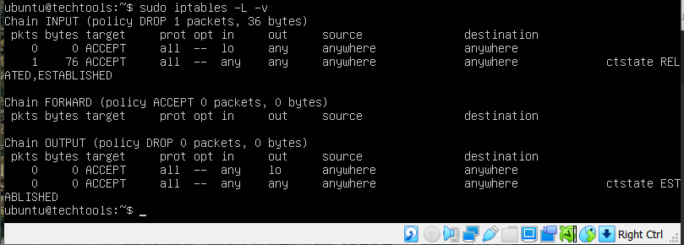  
   mint   
   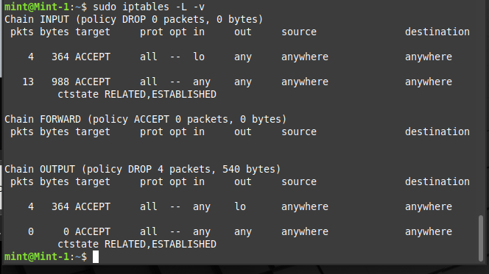
2. Tail command  
   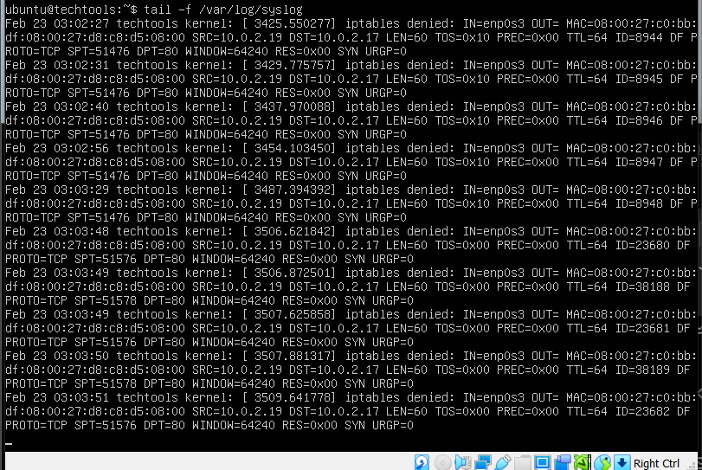
3. Iptables  
   ubuntu server  
   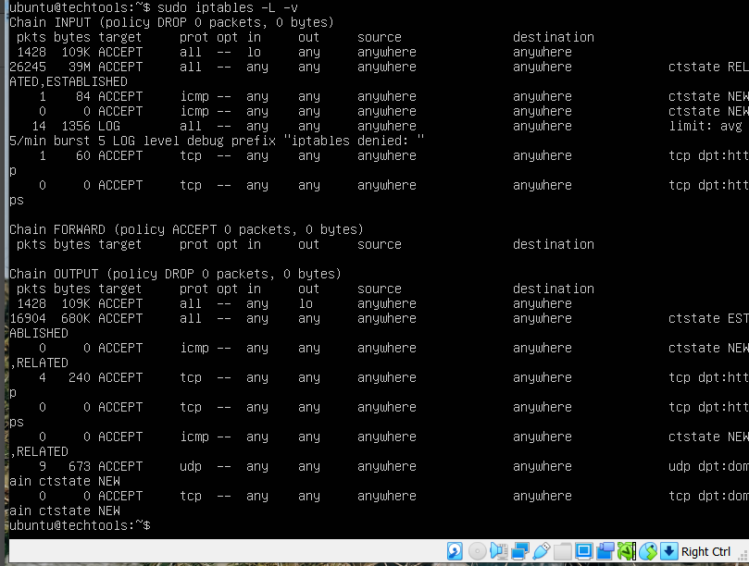  
     
   mint workstation  
   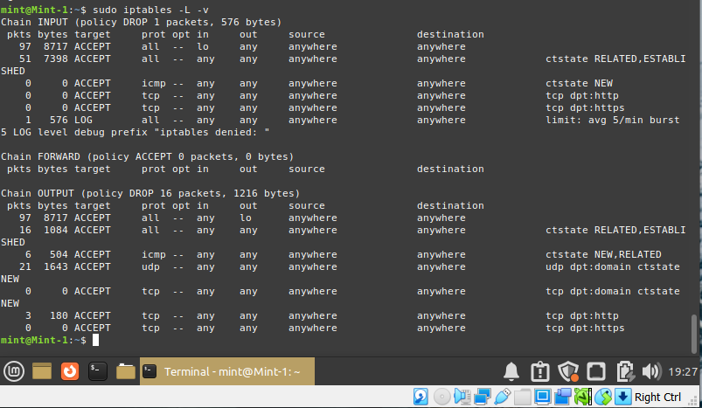

Part 2

Command would be

sudo iptables -A INPUT -p tcp --dport 80 -j ACCEPT

This allows inbound traffic on port 80 which is the port for http requests